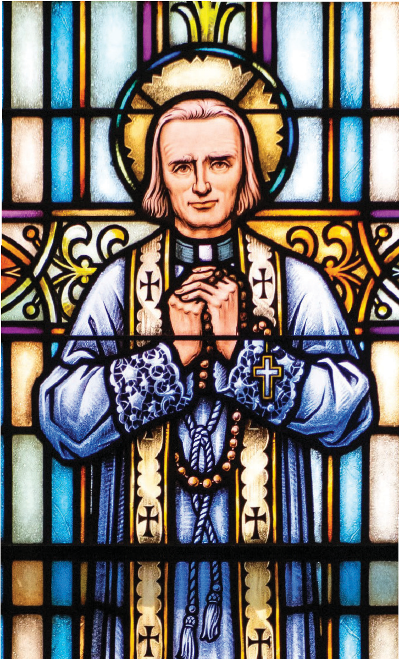

PRAYER FOR VOCATIONS
Heavenly Father, Lord of the harvest, call forth vocations to the priesthood and consecrated life from our parishes. Inspire men to imitate Jesus Christ the Eternal High Priest in sacrificial service to Your Church.
Move the hearts of men and women to offer themselves wholly to You in poverty, chastity, and obedience. Send them as laborers for Your harvest. Inspire the faithful to support them with prayer and sacrifice. Raise up holy families who foster openness to Your call. We ask this through Christ, Our Lord. Amen.
Mary Immaculate, pray for us. St. John Fisher, pray for us. St. John Vianney, pray for us.

Diocese of Rochester

